C19349793 Saul Burgess

*Building a PC: FInal report*

Table of Contents

Introduction: 2

History of the modern Personal Computer: 2

Description & Assembly: 3

Central Processing Unit: 4

Installing the Central Processing Unit 4

Heat Sink: 6

Installing the Heat Sink: 6

Random Access Memory: 8

Installing Random Access Memory: 8

Motherboard: 10

Installing the Motherboard: 10

Power Supply: 12

Installing the Power Supply: 12

Hard Drive: 13

Installing the Hard Drive: 13

Wiring in a Modern Computer: 15

SATA (Data) Cable: 15

MOLEX (Data) Cable: 16

PCIe (Power) Cable: 17

GPIO (Data/Power) Cable: 18

Operating System Installation (Windows/xUbuntu): 19

Windows Installation: 19

Linux Installation to a Prescribed Standard: 21

Six Useful Linux Commands: 22

Appendices: 24

Appendix A: 26

Appendix B: 27

Appendix C: 28

Appendix D: 29

# Introduction:

This document describes the process of researching and constructing a modern Personal Computer. This document will:

* Give a short history of the Personal Computer
* Give a short description of each Computer component
* Give a description of assembling a Personal Computer
* Describe the install of Windows
* Give a description of installing service pack 1 on a Windows operating system
* Give a description of the process of installing Linux *(xUbuntu)* to required specifications alongside Windows
* Describe six Linux commands and their uses

In addition, there will be several appendices to this document describing separate topics:

* Create a plan for a Personal Computer
* Calculate the power consumption of the above Computer
* Describe the importance of *Electrostatic Discharge* in Personal Computer assembly
* Describe various tasks in reference to the Raspberry PI

## History of the modern Personal Computer:

A Computer is a device for storing and processing data, according to instructions given in a variable program. [1]

The earliest evidence of the concept of ‘Computer’ is found in the 19th century with Charles Babbage and the Analytical Engine. Computers can be classified into three separate eras, defined by major developments in Computer Science. [2]

* 1937-1946: Development of the first general purpose computer called “ENIAC” (Electronic Numerical Integrator and Computer). [2]
* 1947-1962: Development of the transistor, which replaced vacuum tubes. These were far cheaper and more reliable. [2]
* 1963-Present: Development of the integrated circuit, allowing for incredible miniaturisation of Computers. Allowing for computers to be reduced from room sized to, eventually, pocket sized computers. [2]

Computers have become endemic to modern life - they are an infinitely useful tool that will continue to develop over the course of history.

# Description & Assembly:

Below is a diagram of a modern Personal Computer.

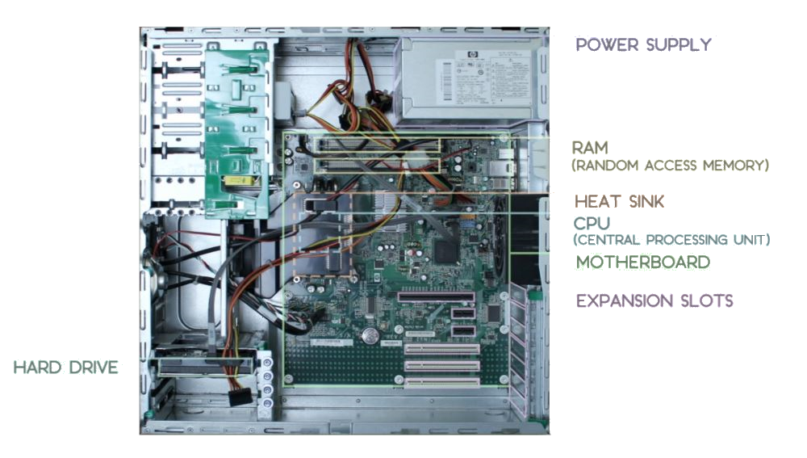

Each of the above components will be described in detail on the following pages.

In addition a page will be allocated to describing the various connectors found in a modern Personal Computer.

Below is a summary of the key components in a modern Personal Computer:

* Motherboard
* Hard Drive
* Central Processing Unit (‘CPU’)
* Random Access Memory (‘RAM’)
* Power Supply

## Central Processing Unit:

The central processing unit is the core element of the computer, it is a general-purpose processer and can calculate a variety of calculations allowing it to perform virtually any task. A Central Processing Unit has limited resources, meaning that separate co-processors for specific calculations may be required. In this system, we will not be installing a co-processer (e.g. graphics card).

### Installing the Central Processing Unit

Place the Motherboard and CPU separately on an anti-static mat, then make sure to ground yourself and the mat independently. Once this is done, make sure your work space is clear and lay out the components as shown.

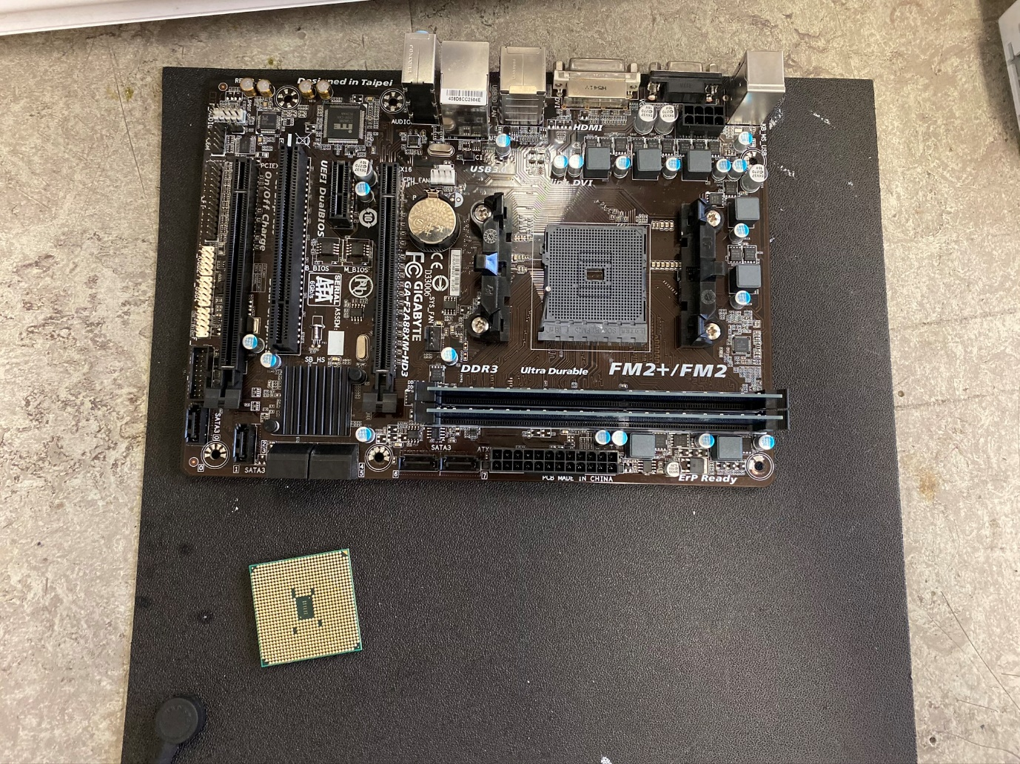

Once this is done, make sure the Central Processing Unit is in the *OPEN* position and carefully install the CPU (the bottom left component) into the slots of the Motherboard. The CPU will sit gently into the Motherboard and will not fit in if placed in the wrong orientation. Do not attempt to drop the lever of the CPU housing until the CPU sits cleanly into the housing. Once the assembly is laid out as shown below continue to the next section.

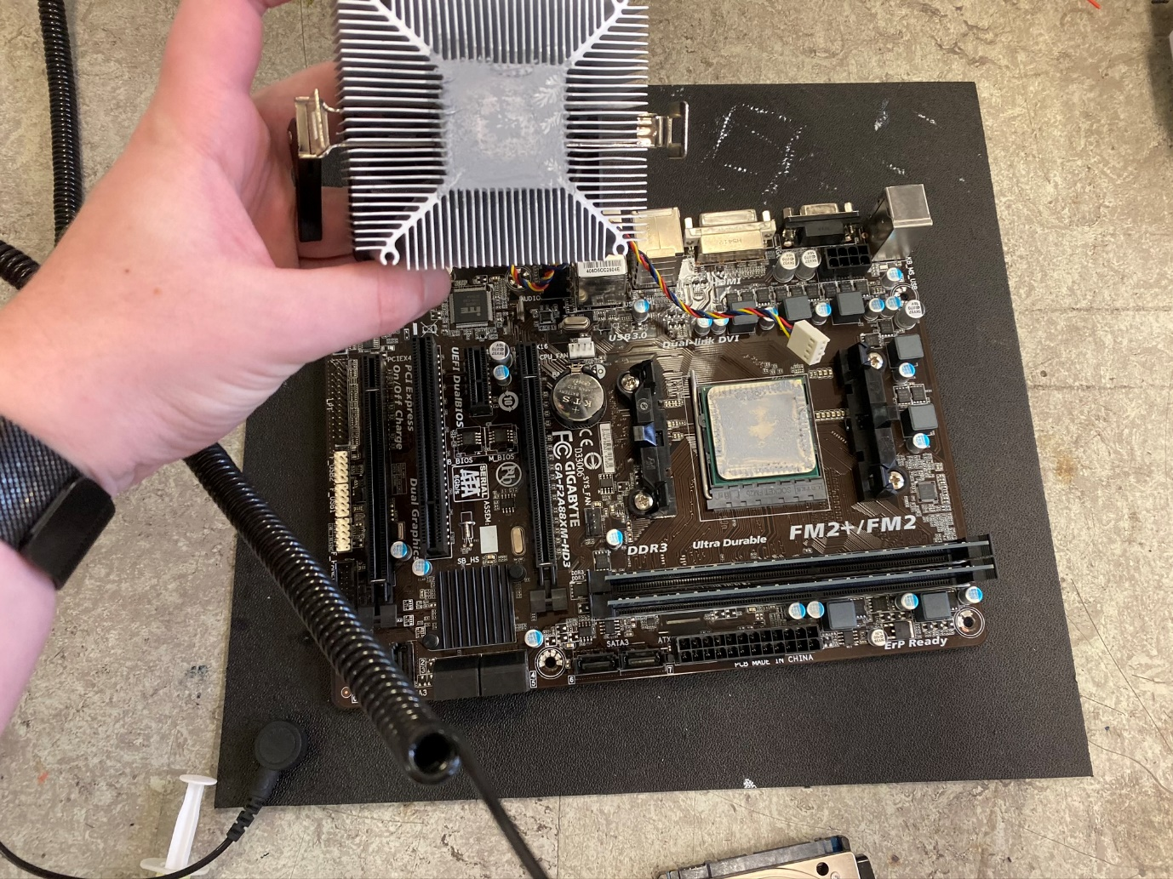

(Note the component in the top left is the “Heat Sink” and will be covered in the next section)

## Heat Sink:

The heat sink sits above the Central Processing Unit and serves to wick away the heat generated by the Central Processing Unit. It usually consists of a veined block of heat conductive metal and an electric fan designed to pull air out of the metal block, cooling the metal block and by extension the Central Processing Unit.

### Installing the Heat Sink:

Installing the heat sink begins with placing a pea sized dollop of thermal paste on-top of the Central Processing Unit, this should be spread evenly in a circular pattern in the centre of the Central Processing Unit. Once done, the assembly should look like this.

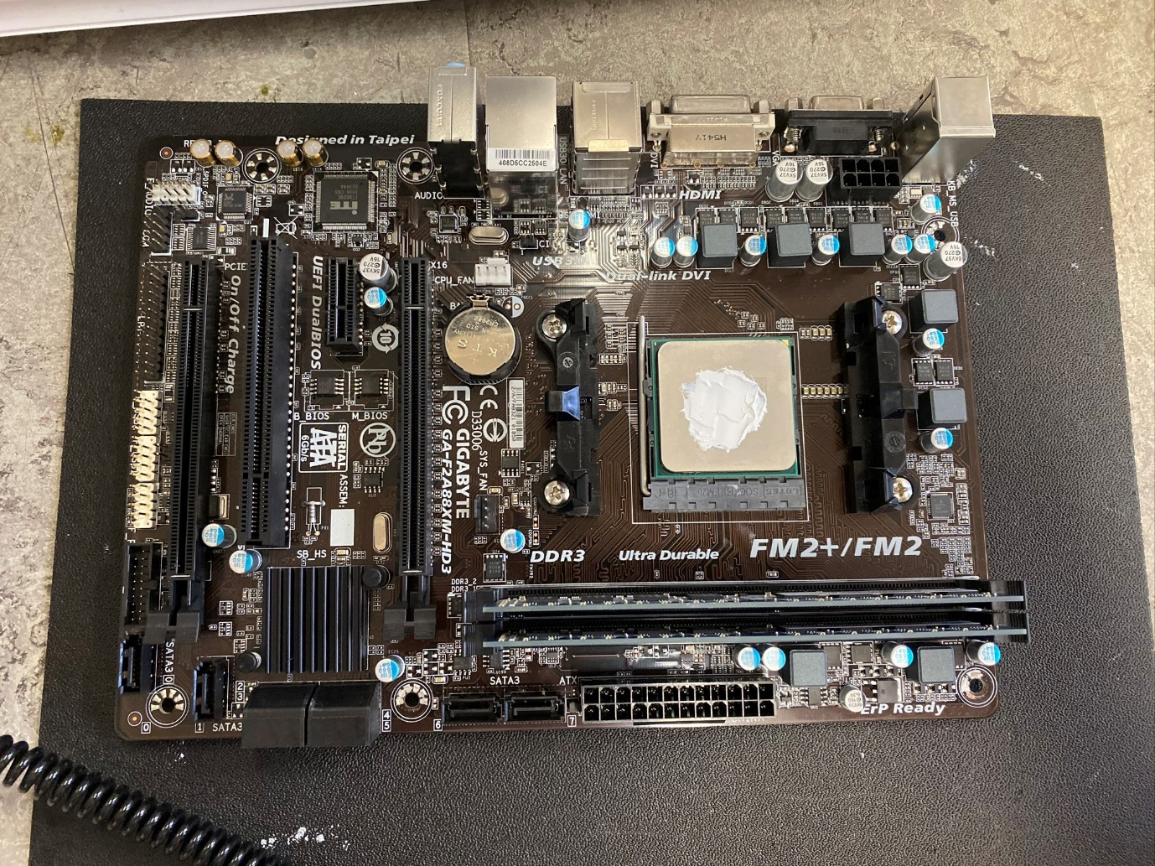

Once completed, take the Heat Sink and place it onto the Motherboard assembly. Then screw the four slots on the corners of the metal block into the Motherboard assembly. Make sure to reconnect the fan power connecter. The assembly should look like the image below when completed.

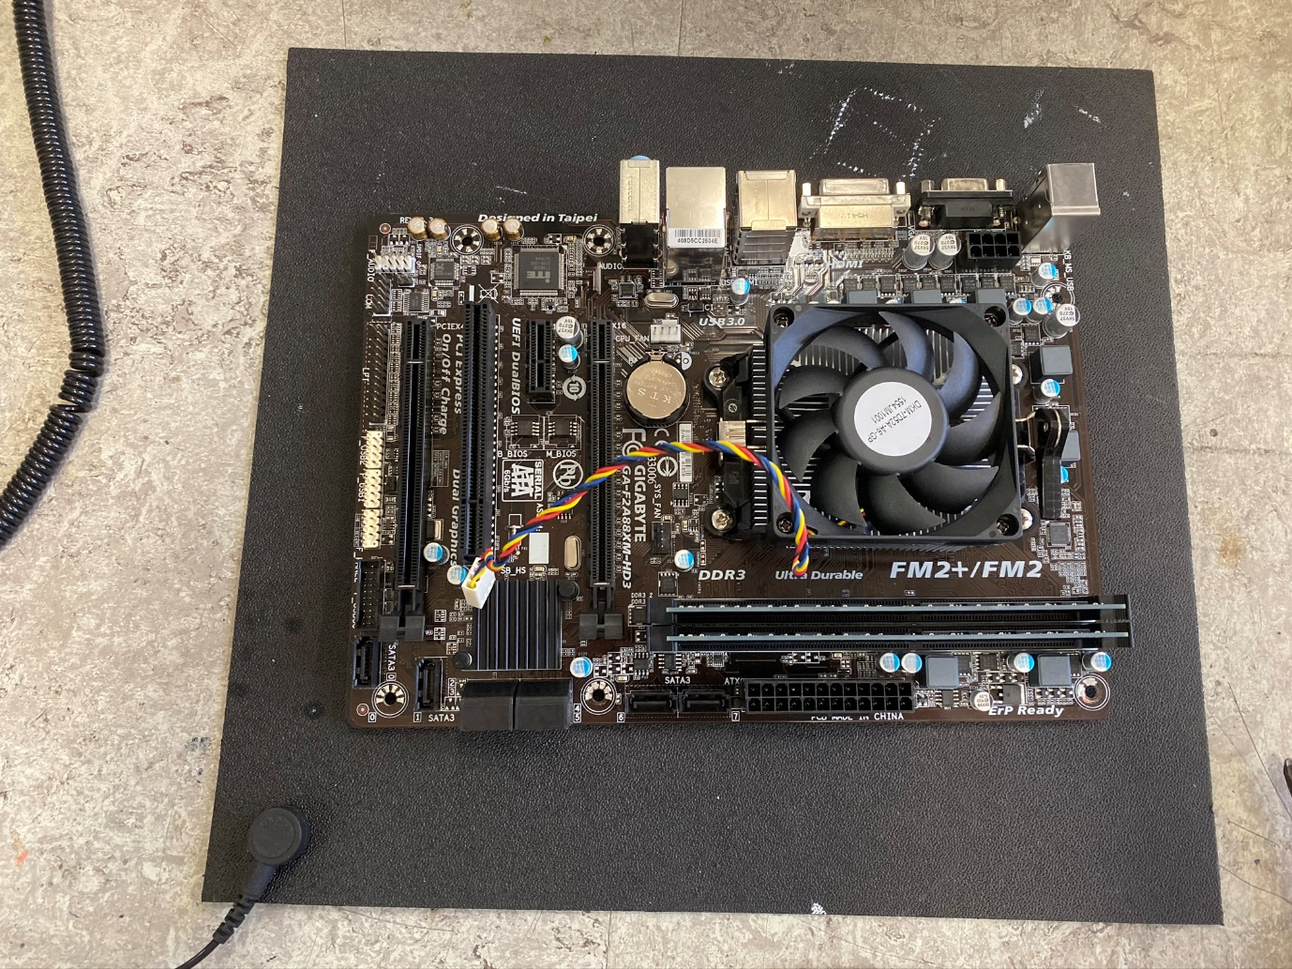

## Random Access Memory:

Random Access Memory stores programs in use inside the Personal Computer. Random Access Memory is volatile memory, and the information stored will be lost when the computer loses power. RAM is a faster form of memory then the Hard Drive, but its volatility makes it impractical for long term information storage.

### Installing Random Access Memory:

Random Access memory comes in the form of small cards, most commonly referred to as ‘Sticks’. Installing them is as simple as placing them into the receptacles of the Motherboard. A RAM stick looks like this:

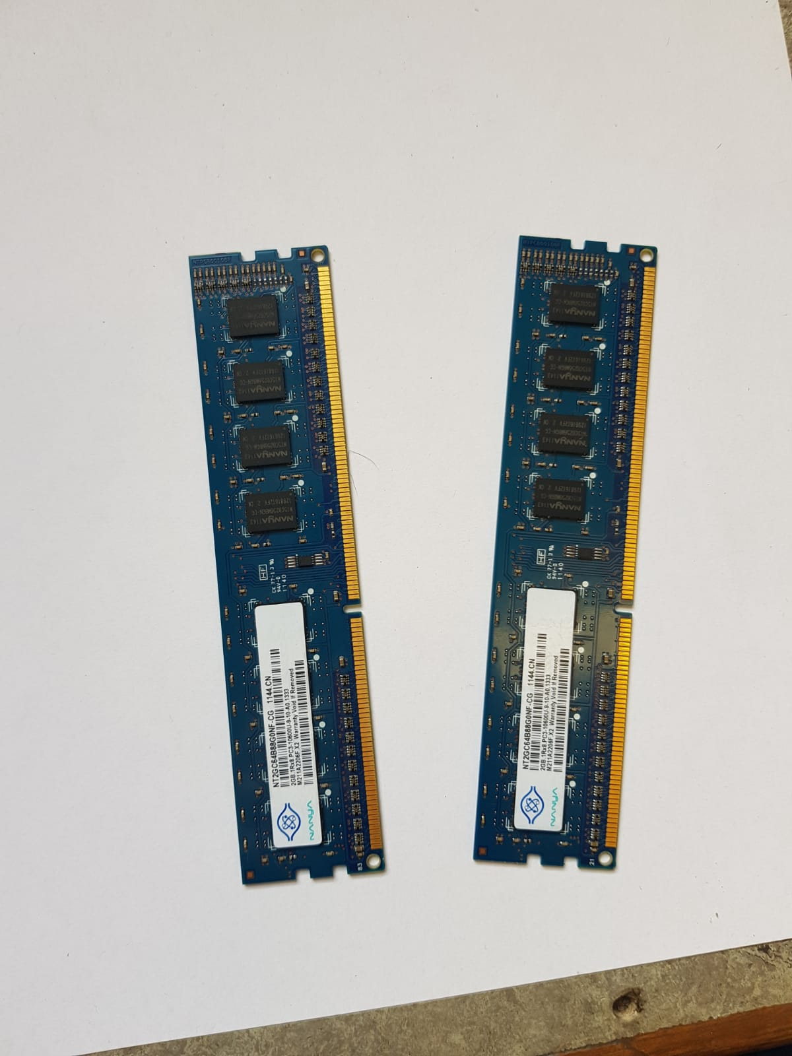

To insert a RAM stick, press the stick into the slot on the Motherboard. Note that the locks will not engage unless the RAM stick is in the correct orientation. The below image shows the location of the slot on the Motherboard. It is marked in red.

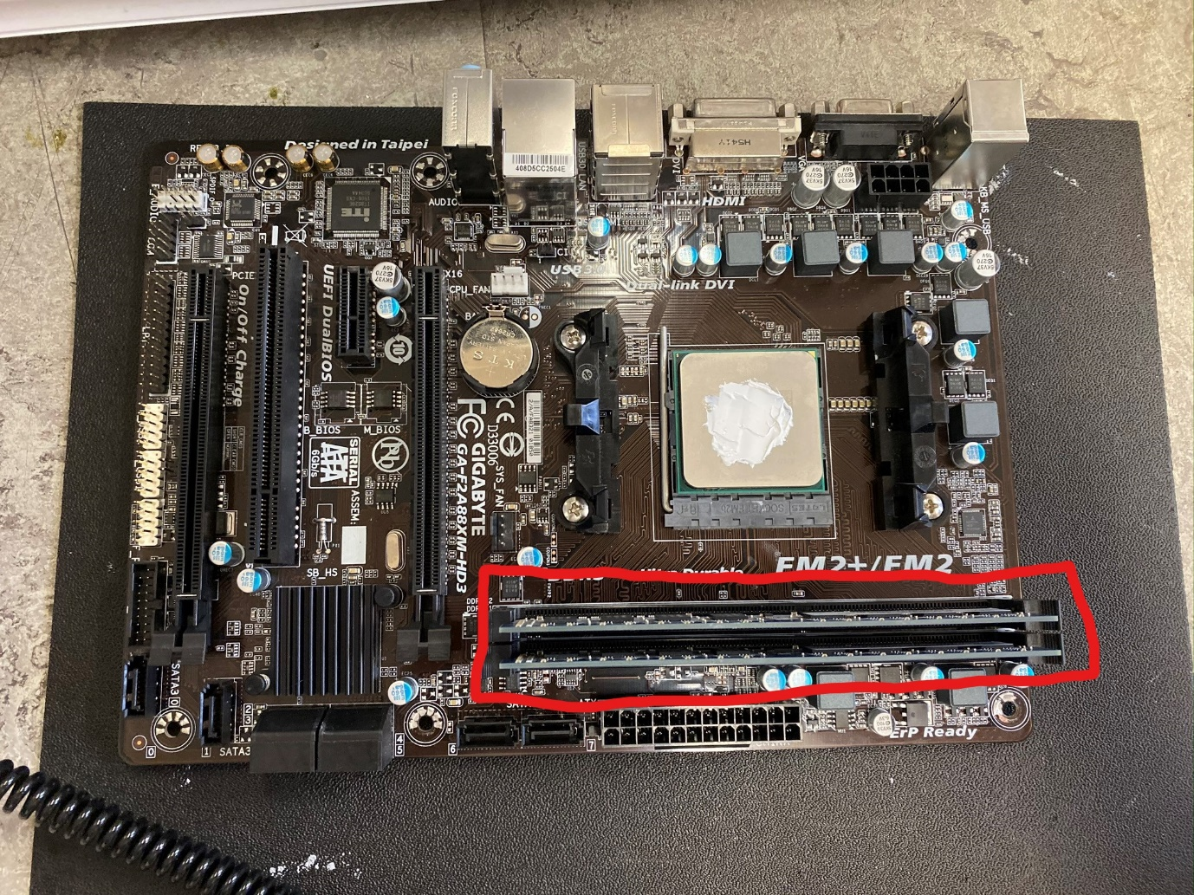

## Motherboard:

The motherboard is the heart of the modern Personal Computer, it serves as a receptacle for all other components of the Computer. The Motherboard hosts the Binary Input Output System (‘BIOS’) – this serves as a layer between the software of the Operating system and the hardware of the Computer, this is called the firmware.

### Installing the Motherboard:

Once the previous parts are completed, you must locate four metal slots on the Personal Computer case. The metal pins are marked in red.

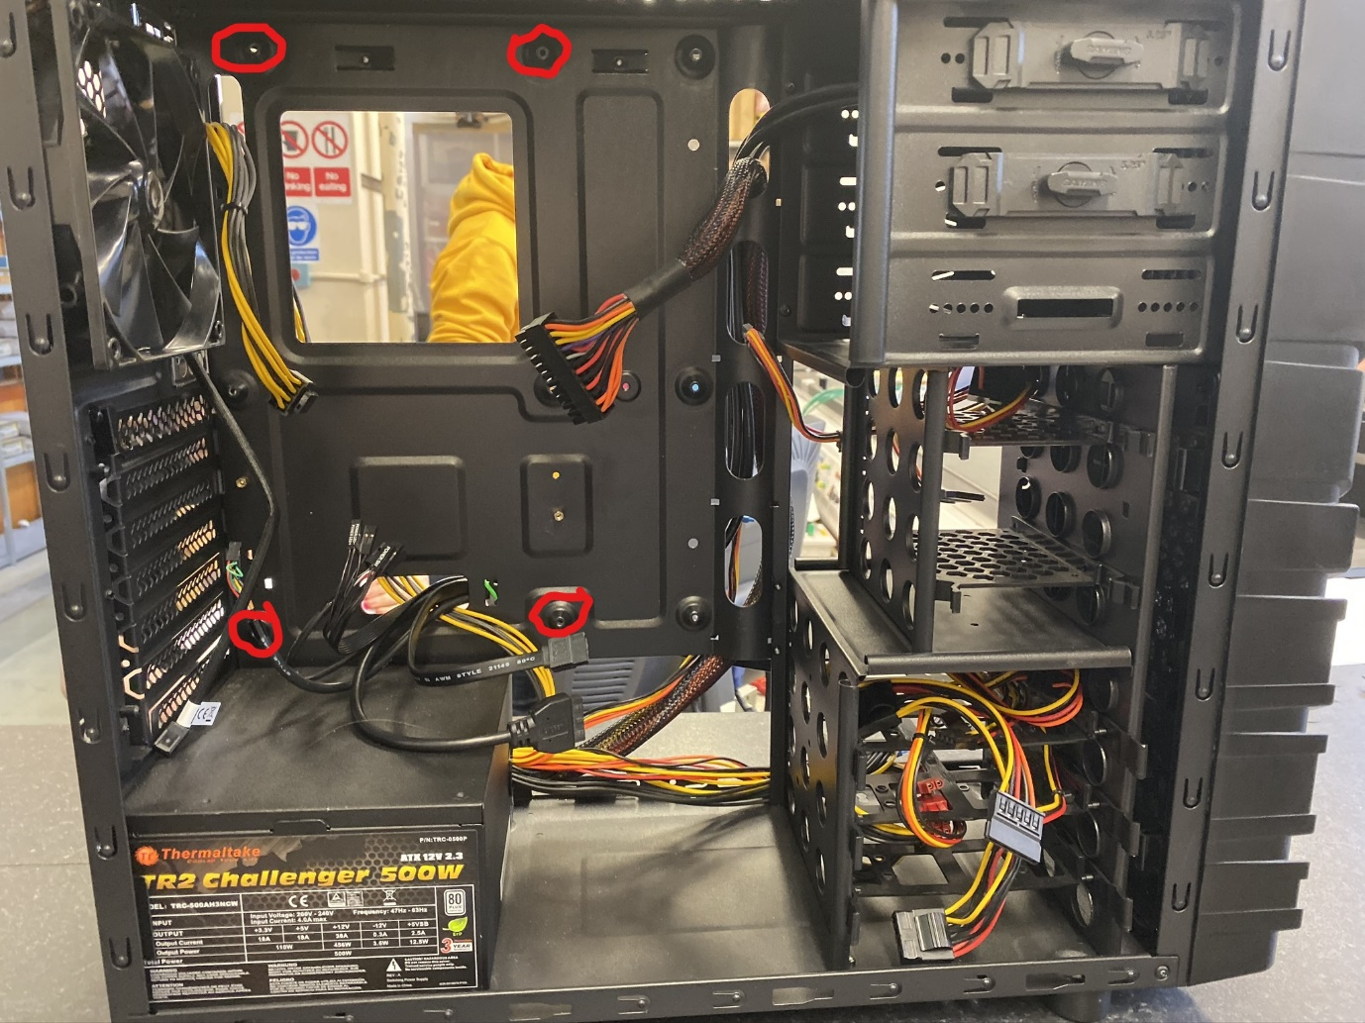

Once located, overlay the Motherboard over the pins. And screw the Motherboard to the case. Once done, the full assembly should look like this.

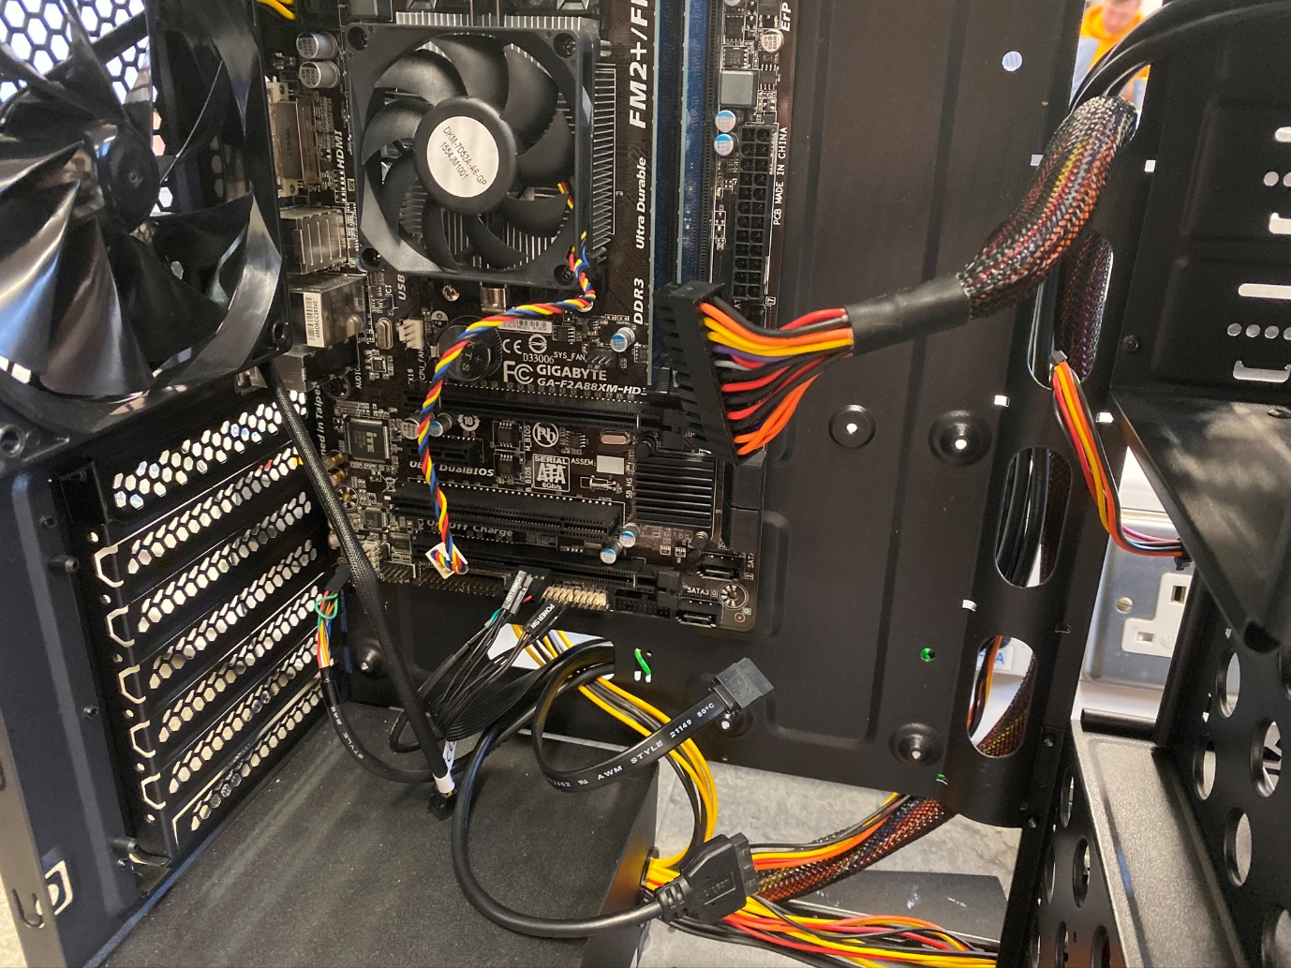

## Power Supply:

The power supply is a transformer that translates the alternating current from a standard wall plug to the direct current necessary to power the Personal Computer. It connects to all components inside the Computer providing individualised electricity, as each component requires a different voltage.

### Installing the Power Supply:

The power supply is installed by screwing it into the case in the provided area, on the opposite side back of the Power Supply (the side where the wall plug attaches) four holes can be found. Once the power supply is in place as per the below picture, it can be screwed in and installed. The Power Supply is marked in red.

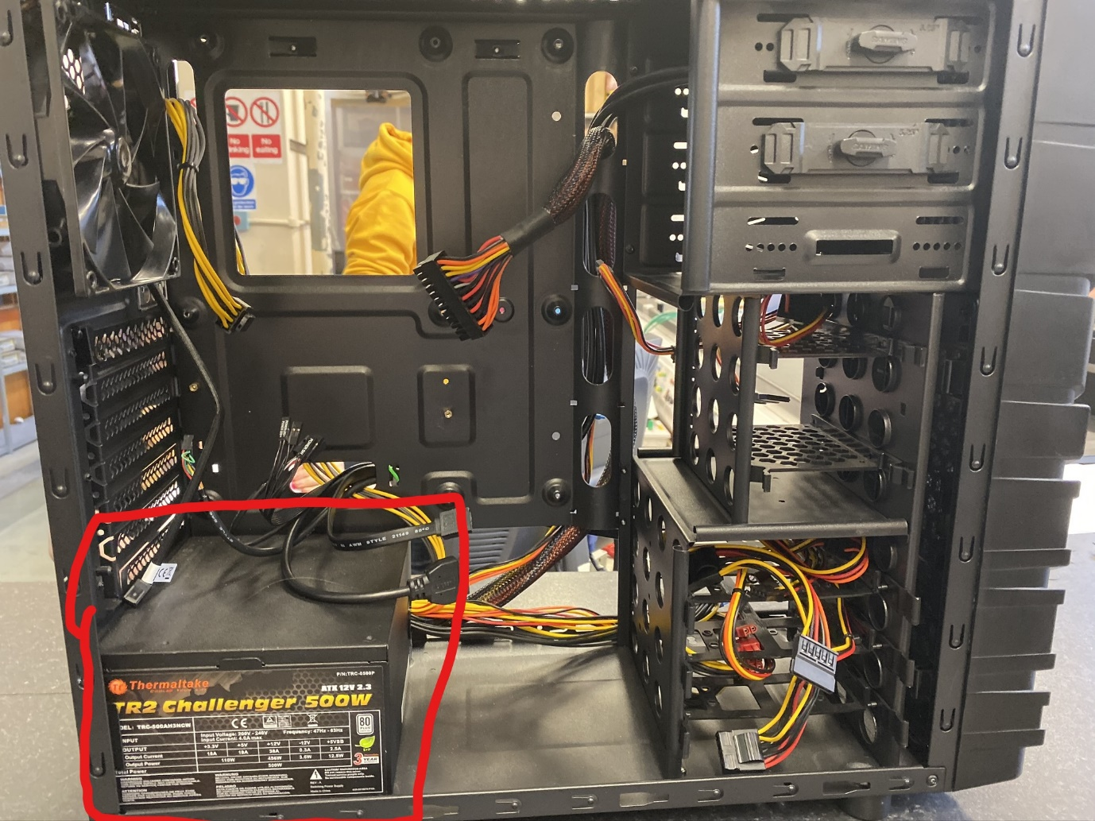

## Hard Drive:

The hard drive is a form of non-volatile and long-term storage in a Personal Computer. It achieves this by spinning multiple disks consisting of glass or ceramic coated in a magnetic surface material. This is segmented into tracks, arms consisting of readers and writers scan the surface of the track writing and reading data from the surface of the disk, by checking and editing the magnetic properties of the disks. The Hard Disk is crucial to the modern Personal Computer as data storage is necessary for all Computer operations.

### Installing the Hard Drive:

Installing the Hard Disk is different in each computer case, some cases may not require any screws others may require you to screw the case into the drive bay.

Below is an image of a hard drive attached to a drive caddy:

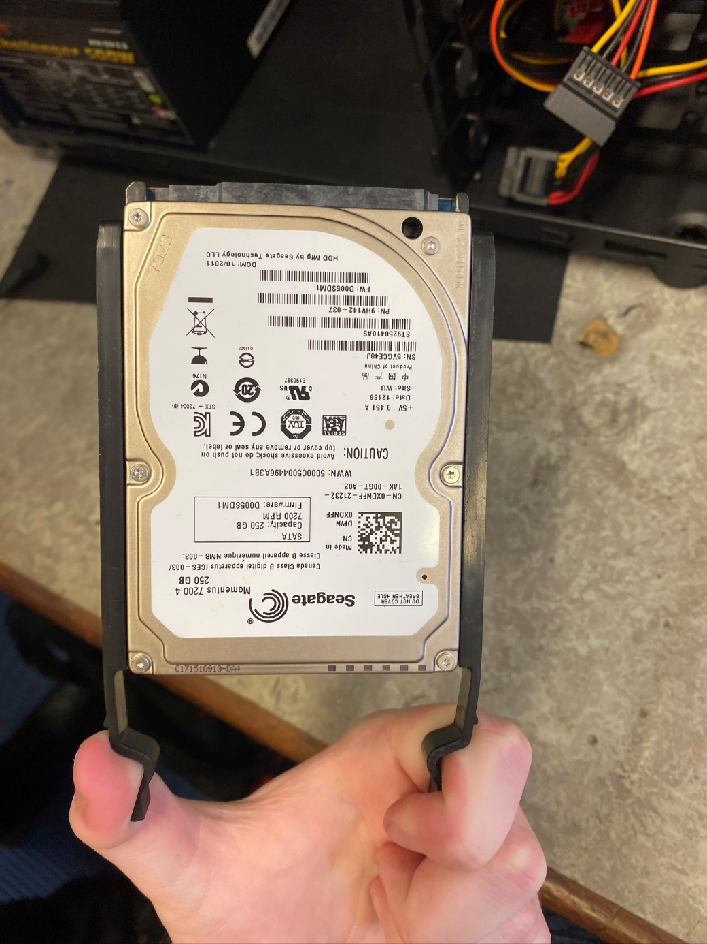

In this example, installation is simple. Simply click the caddy into the drive bay. Once you have attached the power, and data connectors at the back (this will be covered later) the assembly should look like this.

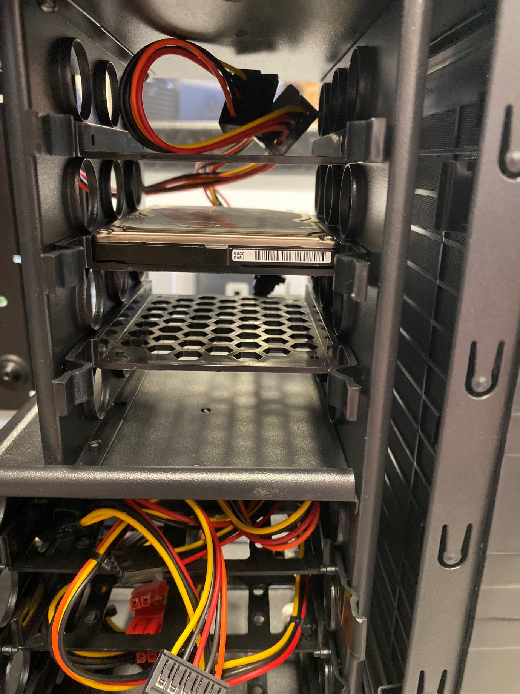

## Wiring in a Modern Computer:

There several types of wire inside a modern computer, cabling falls into two categories, Power and Data. Below is a list of all the cables in a Modern Computer, including their uses.

### SATA (Data) Cable:

The SATA format is normally used to connect the Motherboard to a Hard Drive or Solid-State Drive. Below is an image of a SATA cable.

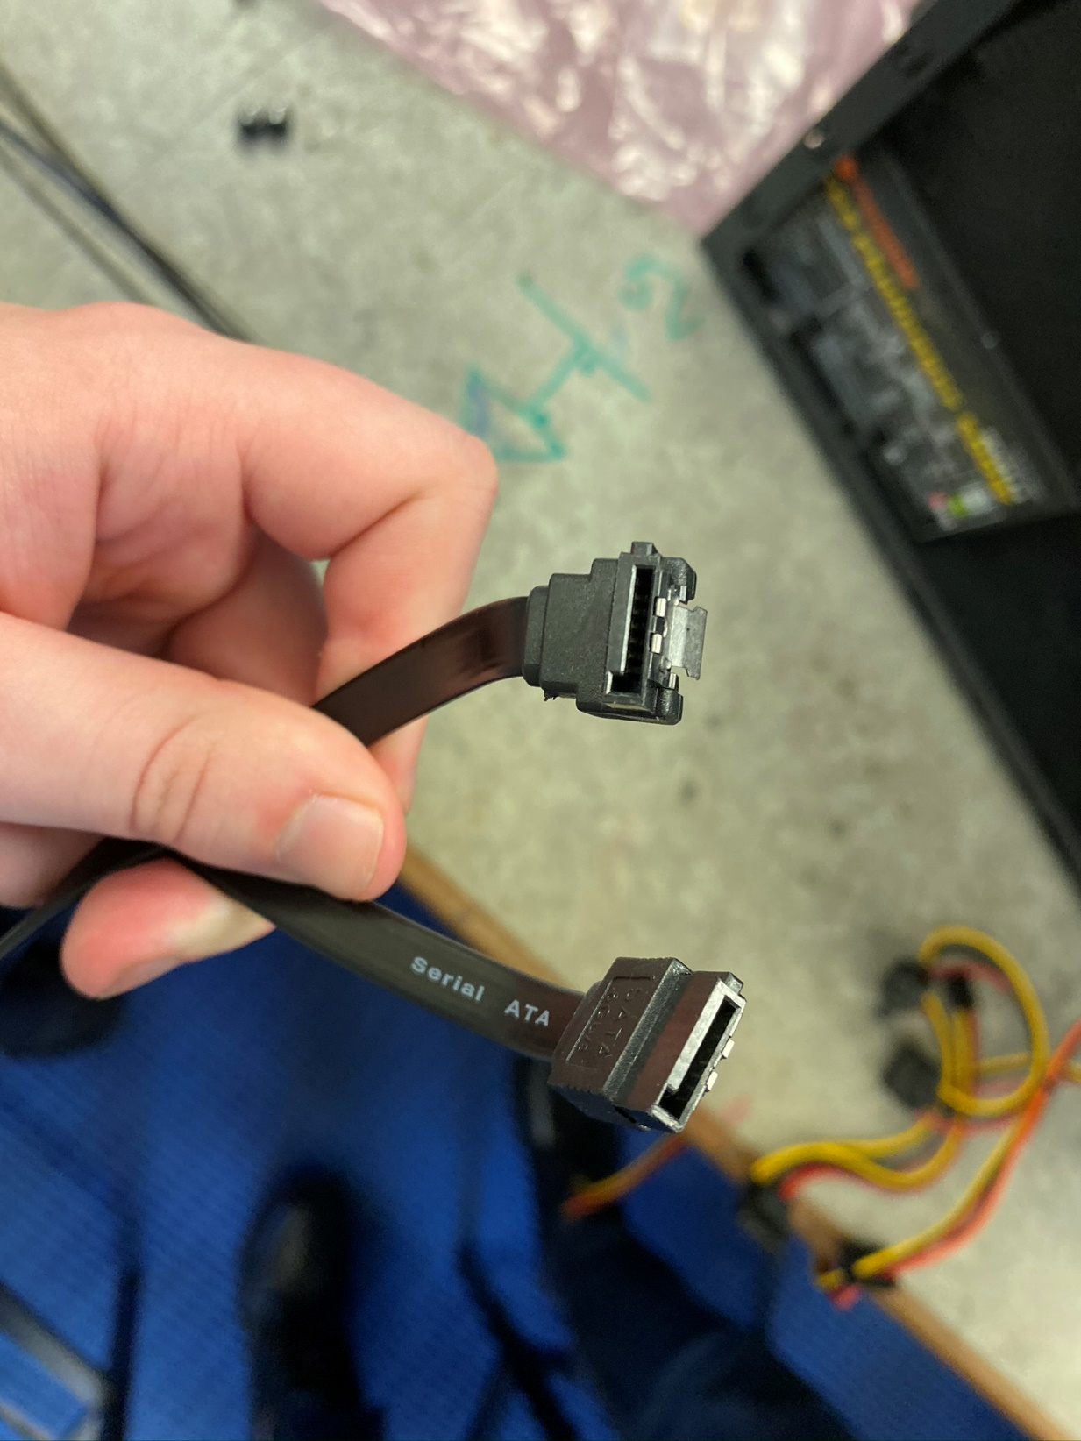

### MOLEX (Data) Cable:

The MOLEX standard is used to connect the Motherboard to a Hard Drive, it is an outdated standard suffering from lower speeds then the newer SATA cables. They are not present on many of the newer Motherboards.

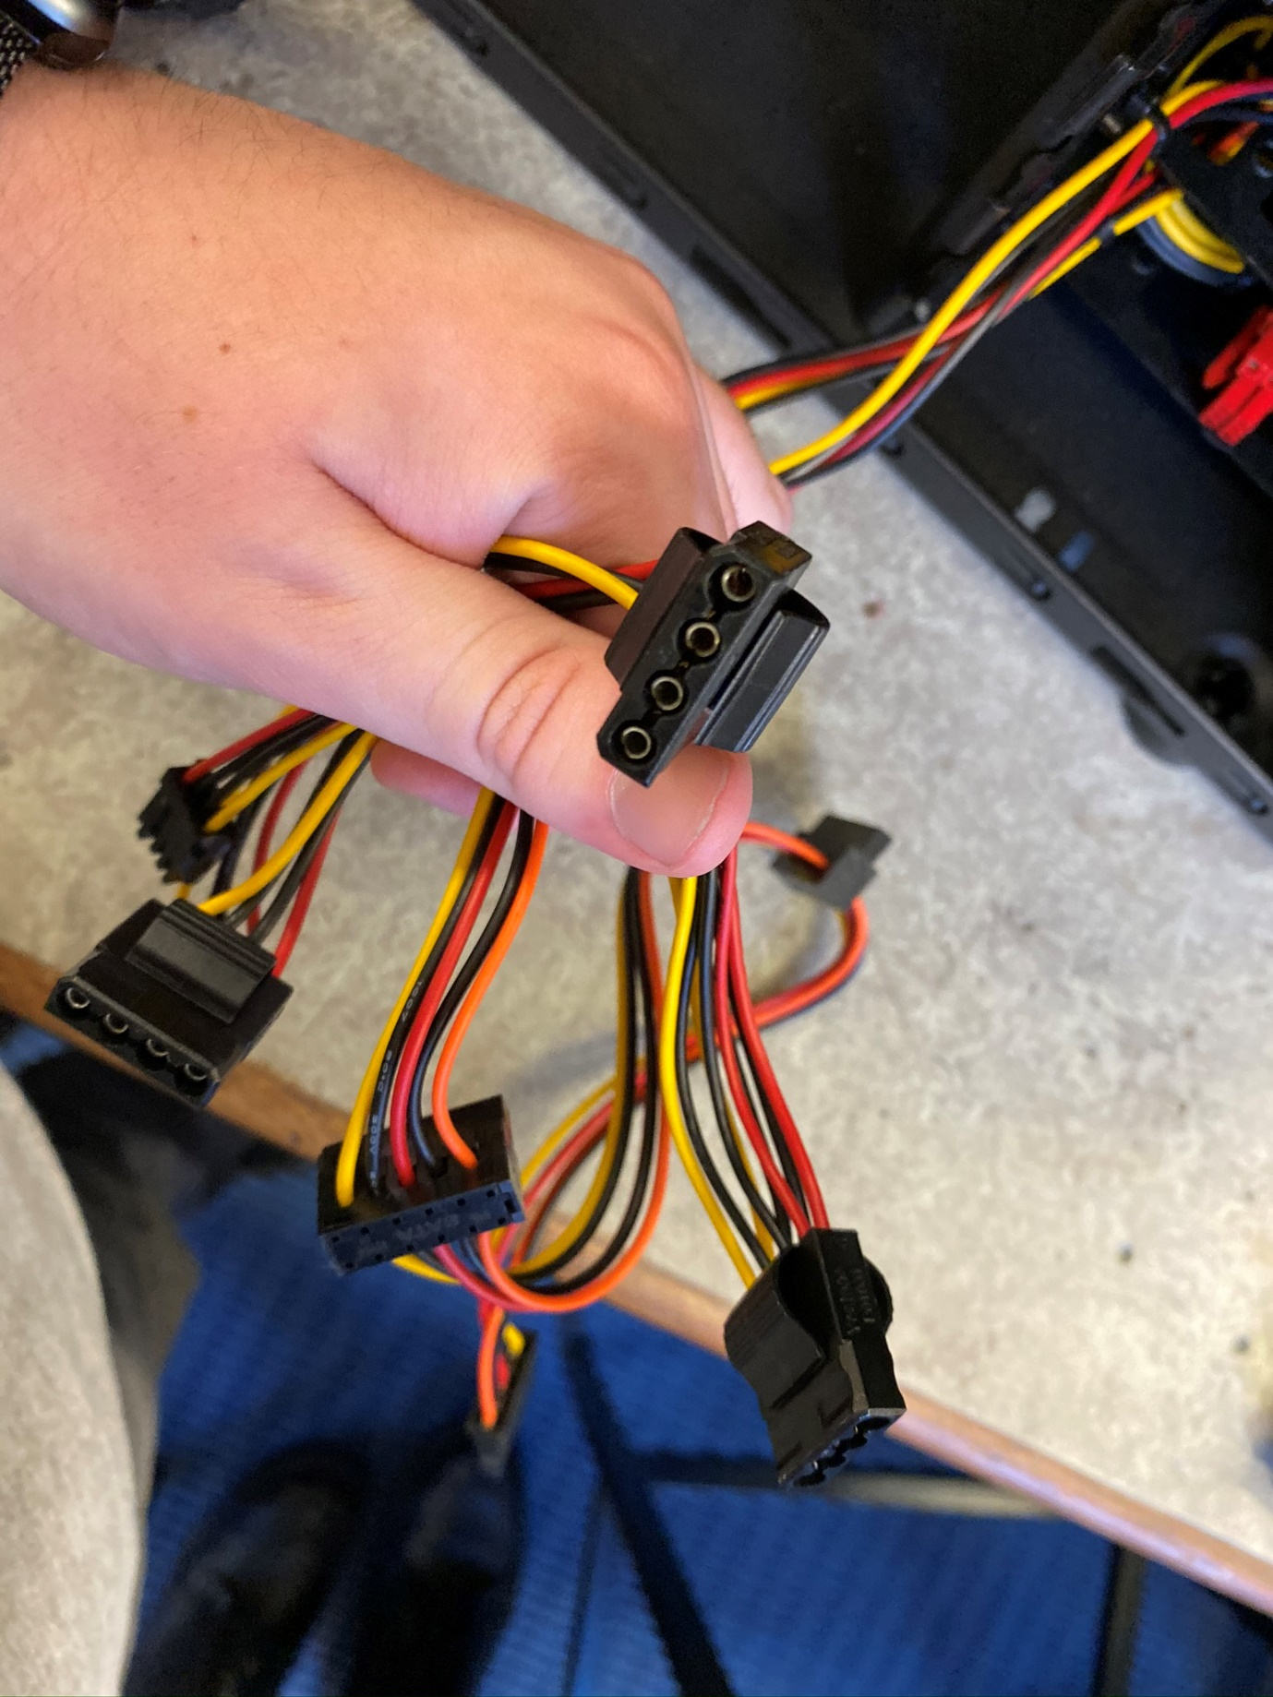

### PCIe (Power) Cable:

The PCIe standard provides electricity from the Power Supply to the Motherboard and all other components of the Computer.

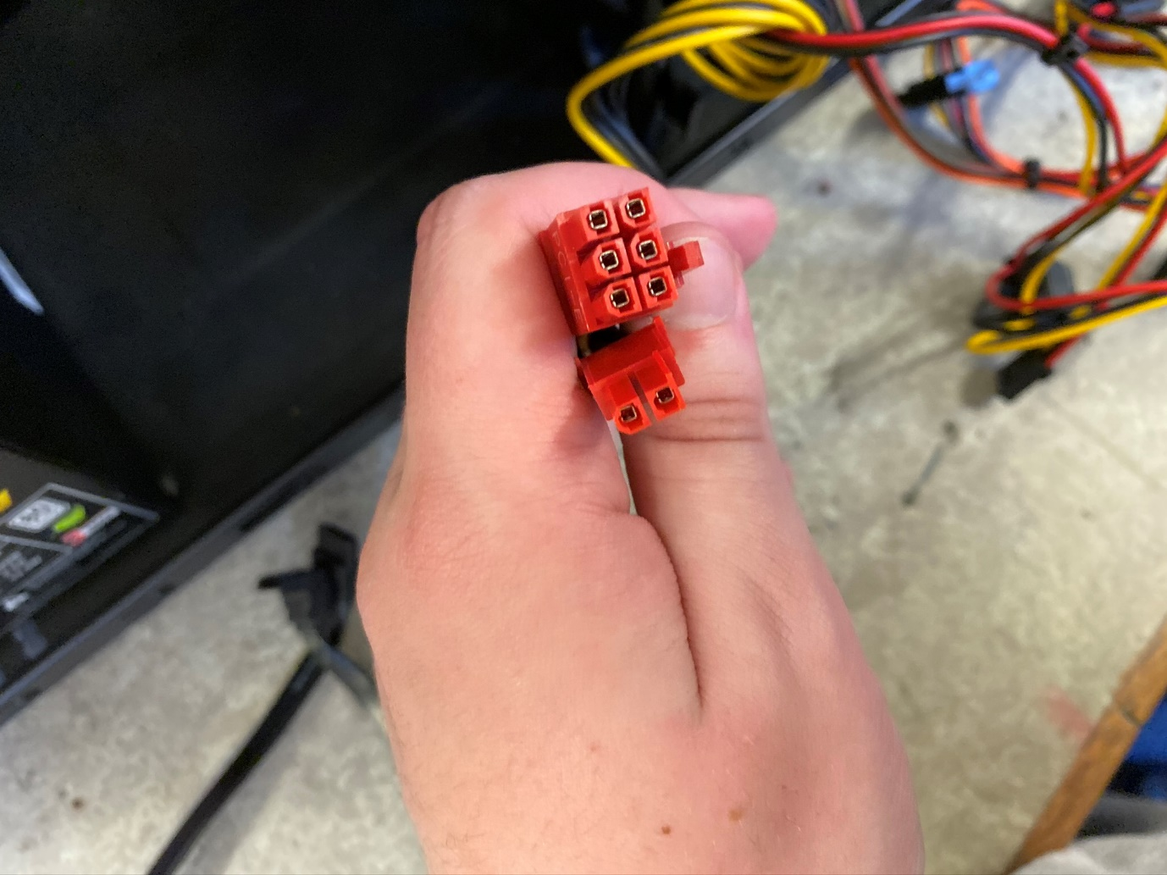

### GPIO (Data/Power) Cable:

GPIO pins transfer data and electricity at very low bandwidth, they are used to power LED’s which are often used to show the status of the Computer. GPIO pins, in specialised arrays, are also used to connect to USB ports. Allowing for easy external access to a computer.

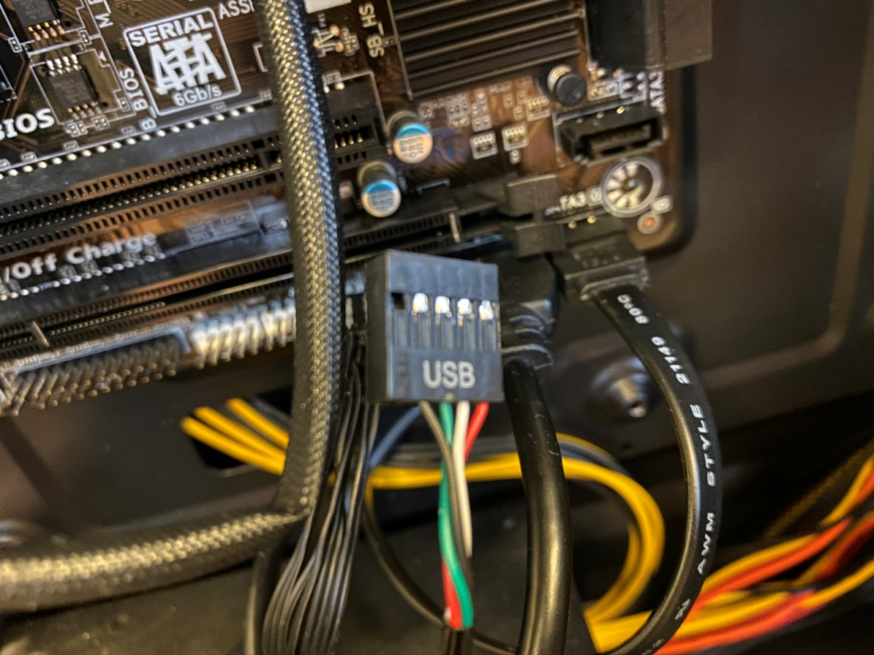

Example of a USB array.

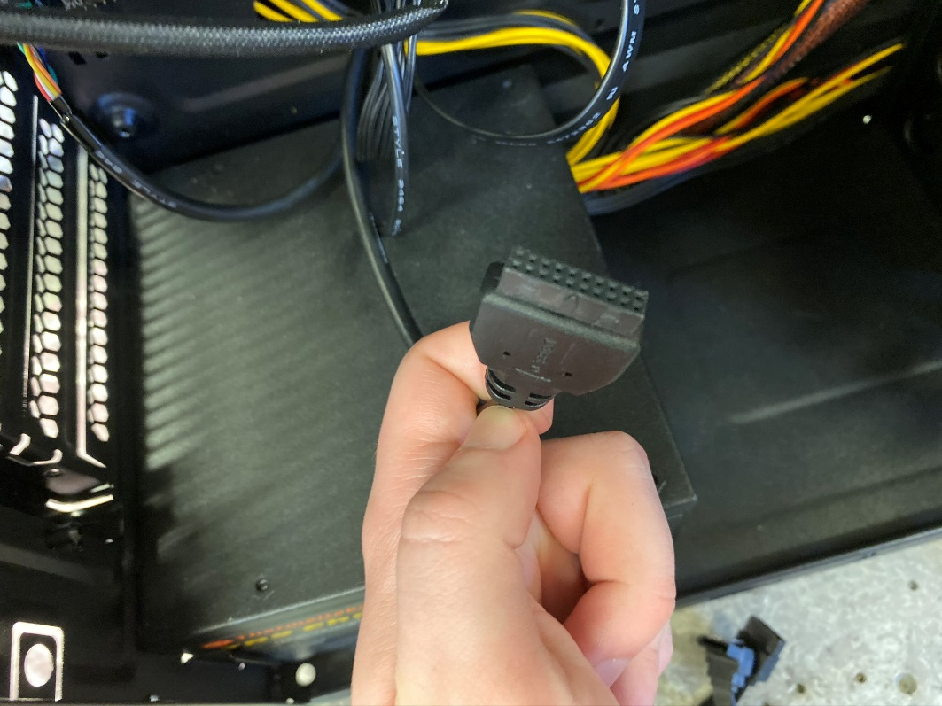

# Operating System Installation (Windows/xUbuntu):

This section will describe the installation of Windows and xUbuntu. Windows will be installed first then xUbuntu will be installed alongside Windows. A description and example of six Linux commands will be included at the end.

To begin the process of installation, simply insert the install media. When the computer boots it will prompt you to install the inserted media.

## Windows Installation:

After insertion of install media. Windows Installation (Windows 7) is almost entirely automated. You will be presented with this screen to setup a user, after this screen you will be prompted to initiate the installation. Below is picture of the setup screen, and the installation.

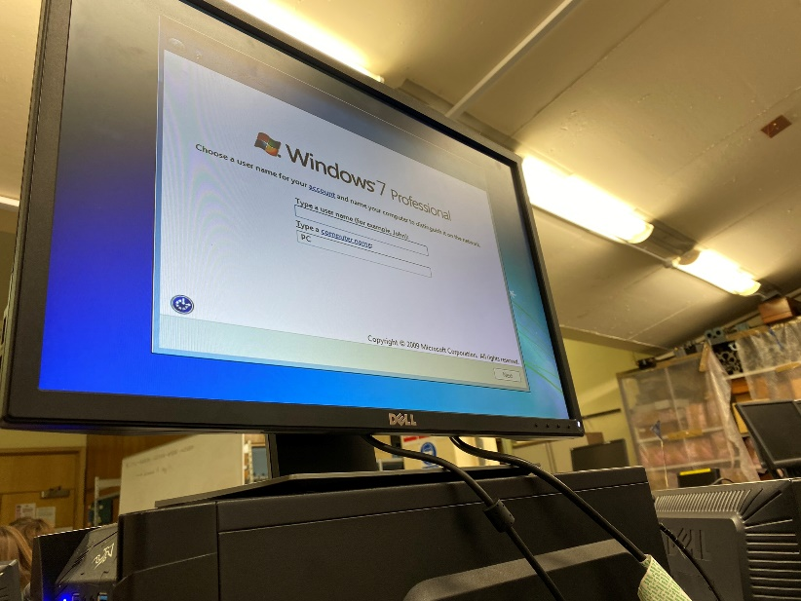

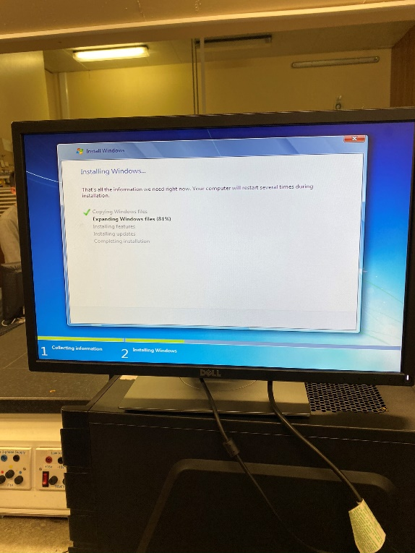

Once completed, you will be presented with the Windows Home screen.

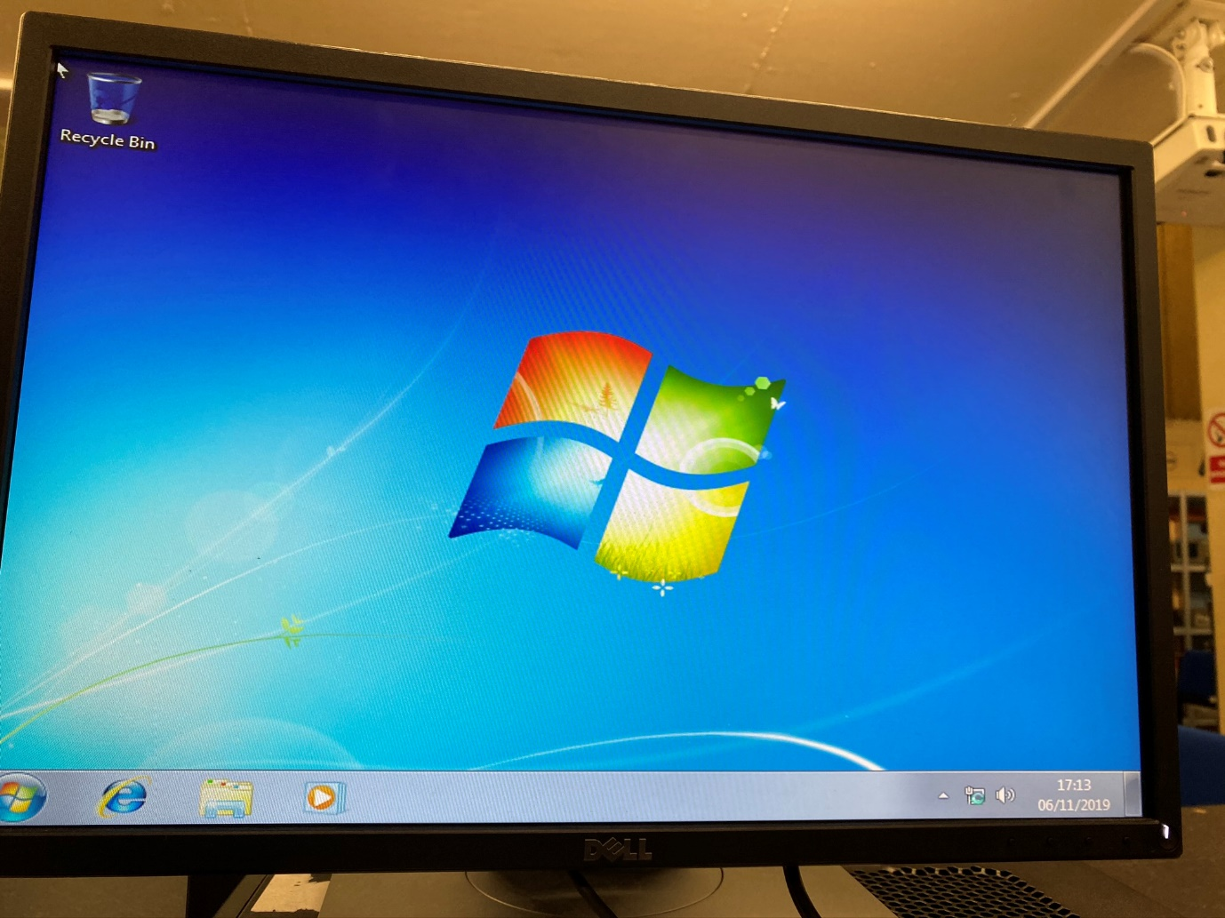

## Linux Installation to a Prescribed Standard:

Linux Installation has a Manual, often called “Custom”, installation path and an Express installation path. As a prescribed standard must be follows, the “Custom” option must be followed.

When the Linux install media is inserted, and the computer is rebooted you will be presented with a configuration screen. First select “Custom” and then configure the partitions to the following prescription.

|  |  |  |  |  |
| --- | --- | --- | --- | --- |
| Partition Name | Size | Mount Point | Subsystem | Partition Type |
| Root | ? | / | Ext 4 | Primary |
| SwapSpace | 8GB |  |  |  |
| HomePartition | 20GB | /home | Ext 4 |  |
| SharePartition | 10GB | /windows | Fat 32 |  |

Once finished, select “Install” and this screen will be displayed.

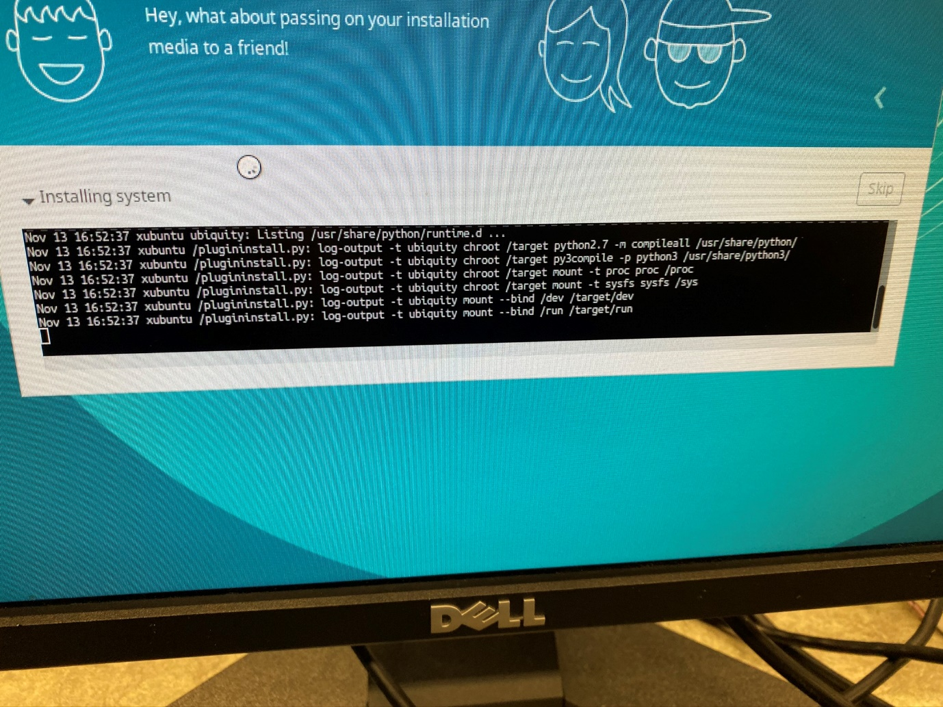

## Six Useful Linux Commands:

Below are six useful Linux Commands. Attached are images of them working and their use.

1.

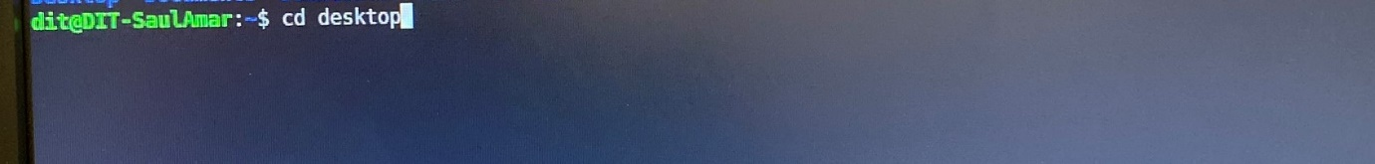

The CD command allows the user to navigate throughout the filesystem of the computer. For example, this cd command will direct the user from the root directory to the desktop directory.

2.

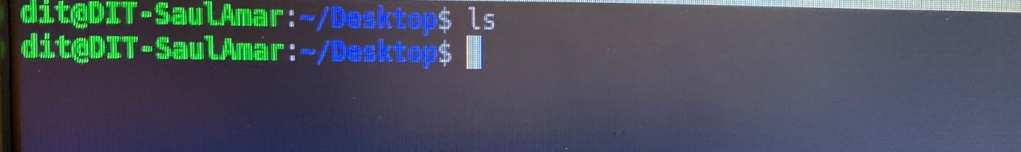

The LS command displays the contents of the current directory. In the above example the Desktop directory is showed to be empty.

3.

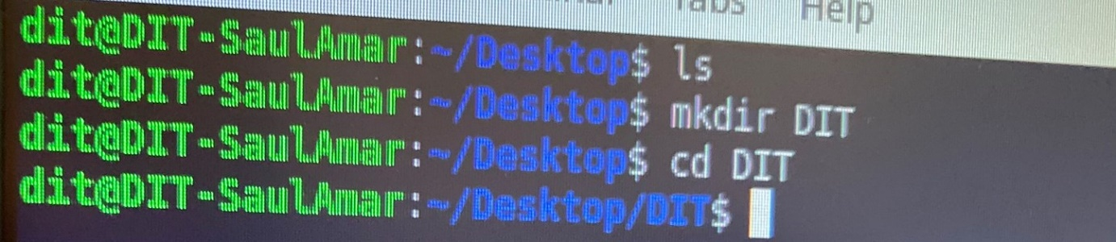

The MKDIR command creates a directory of a stated name in the current directory. This is most commonly called a “file”.

4.

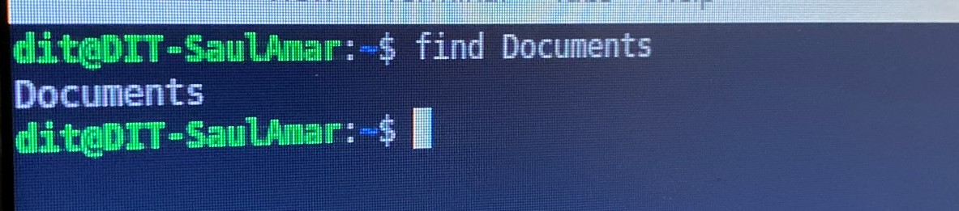

The FIND command followed by the chosen word will show all entries containing the chosen word in the current directory. This can be useful to find files in a directory containing multiple elements.

5.

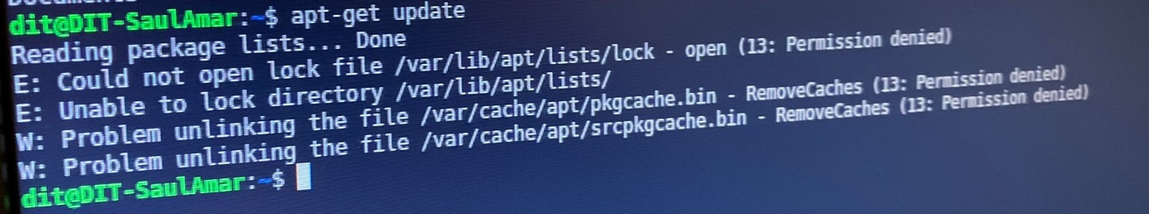

The APT-GET UPDATE command will update all software present on the computer. It is important you do this regularly to keep your Linux computer updated.

6.

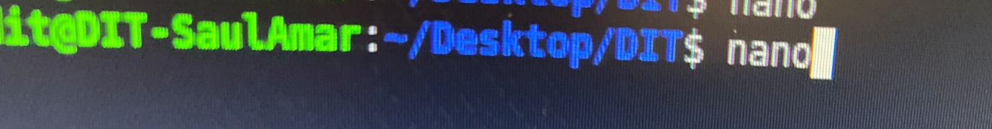

The NANO command opens a Notepad type document. This allows you to program and create documents inside a Linux machine.

# Appendices:

Insert references here at the end

## Appendix A:

“Bill of Contents” for a standard office computer.

|  |  |
| --- | --- |
| Name: | Price (Euro including shipping): |
| AMD Ryzen 3 3.5 GHz Quad-Core [3] | 77.98 |
| ASRock B450M-HDV Motherboard [4] | 59.99 |
| 8GB (2 x 4GB) DDR4-300 Memory [5] | 34.99 |
| MS30 512 GB M.2-2280 SSD [6] | 44.99 |
| 1000 MicroATX Mid Tower Case [7] | 39.99 |
| Corsair CXM (2015) 450 W 80+ [8] | 64.98 |
| LG GH24NSC0 DVD/CD Writer [9] | 17.99 |
|  |  |
|  | Total: |
|  | 340.91 |

## Appendix B:

“Energy Consumption” of a single, and 100 computers.

In this calculation, the processer is likely to contribute the most to the energy bill of the given computer.

|  |  |
| --- | --- |
| Cost of running one machine for one year. | Cost of running 100 machines for one year. |
| 47.75 Euro a Year | 4,775 Euro a Year |

## Appendix C:

Electrostatic Discharge is the process where electrical differences between two surfaces causes electricity to flow between those two surfaces, so that the electrons can be grounded. Normally, this is a mild inconvenience and may only result in a tingly shock. However in computer systems it can cause major damage.

Electrical Circuits use diodes, and channels to force the electrons within a computer to move in specified directions. If electrostatic discharge occurs, this may cause the electrons to move in non-standard ways causing damage to components, or in the worst case, destruction of the component.

Electrostatic Discharge can be prevented by:

* Leaving your Power Supply Unit connected but switched off.
* Avoiding working in carpeted rooms.
* Touching a metal or conductive surface before handling components.
* Working on a hard or solid surface.
* Using a grounded ESD mat (pictured in assembly)
* Wearing an anti-static grounded writsband.

## Appendix D:

The Raspberry PI is a miniature computer based on a “System on a Chip” architecture. Below is a method of connecting it to a prepared Personal Computer over an Ethernet cable.

Begin by connecting the Raspberry PI to a HDMI monitor and keyboard. Once done run the “ifconfig” command. Pictured Below.

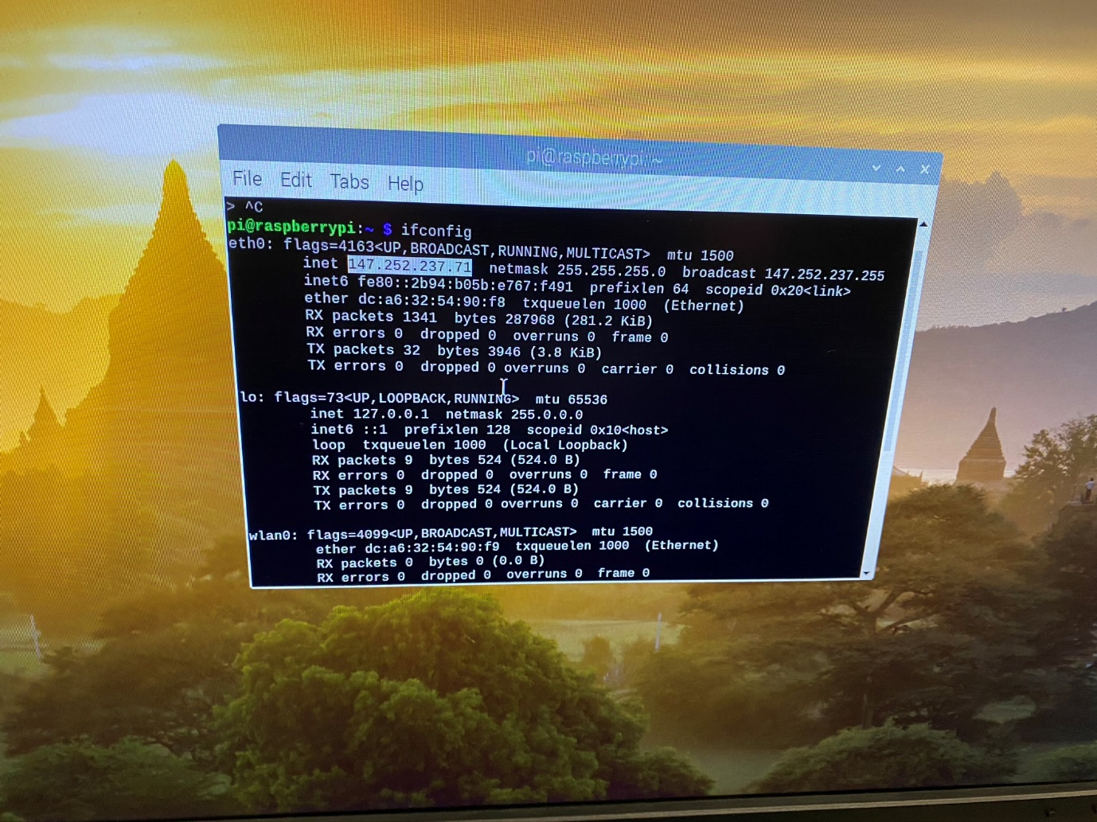

Once you have copied down the highlighted text, enter the raspberry pi’s configuration settings and enable SSH Remote Command Line access. Pictured below.

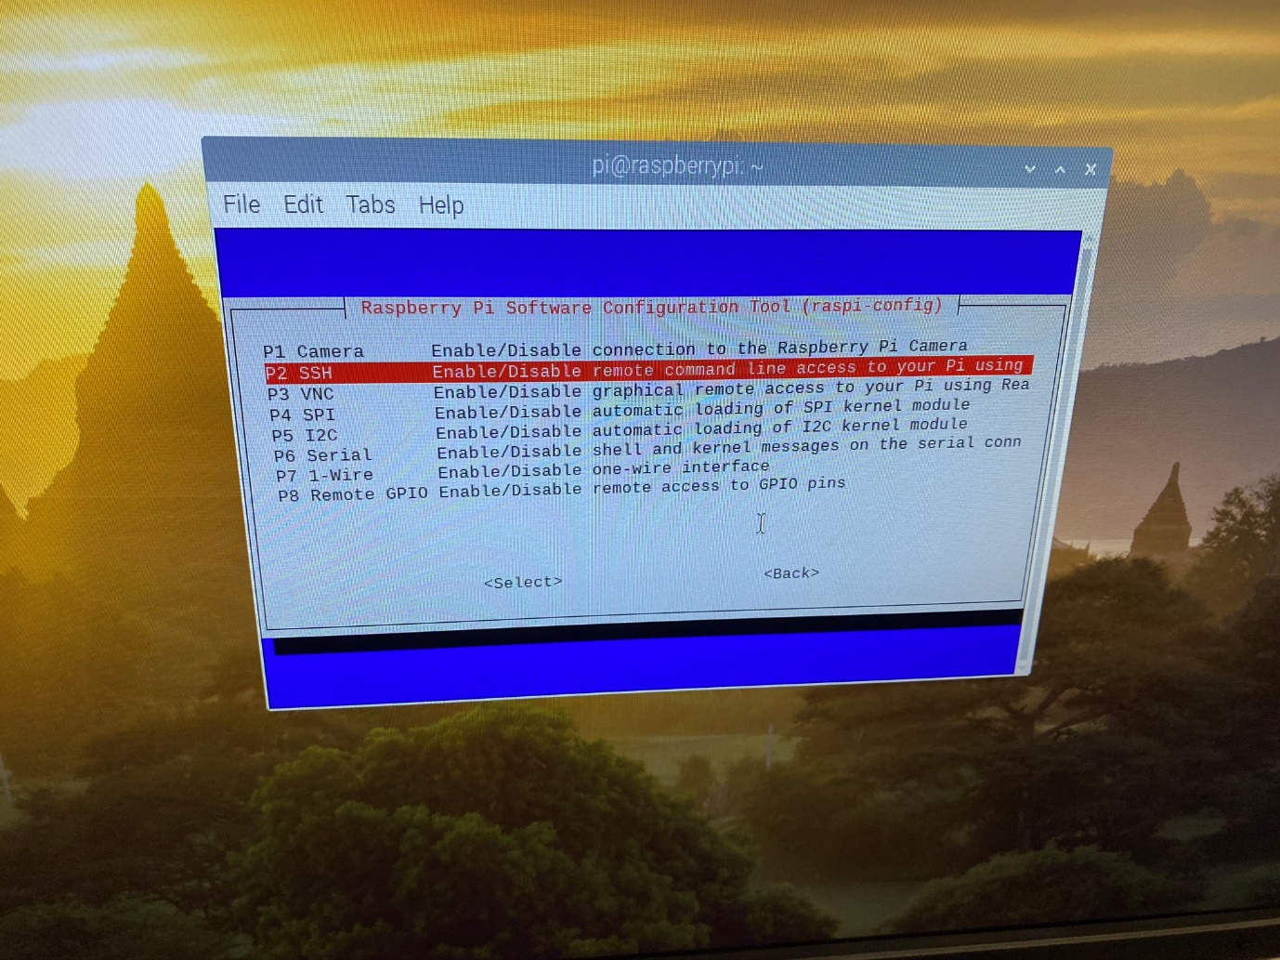

Now return to your Linux machine, and type “SSH [pi@xxx.xxx.xx.x](mailto:pi@xxx.xxx.xx.x)” replacing the “x” with the address of the raspberry pi. Once this is done you will be prompted for a password, the default password is “Raspberry”.

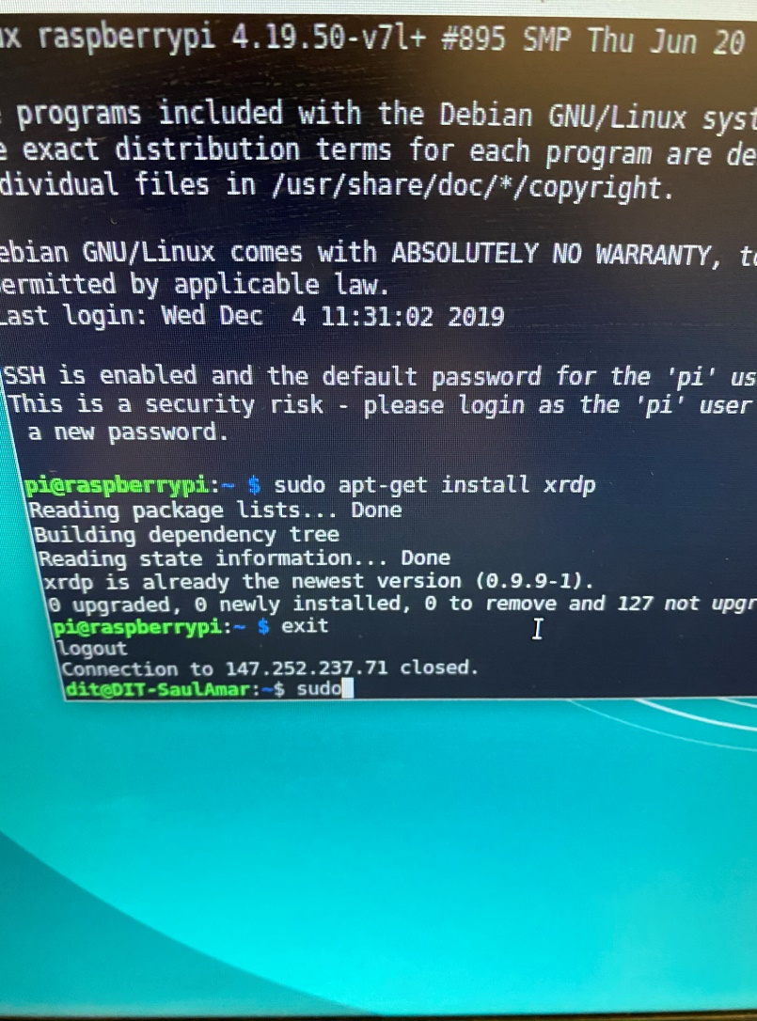

Once you have entered in the password, you will be greeted by the command line interface of the PI. Pictured below.

